**RESUME**

**C. Santhiya,** 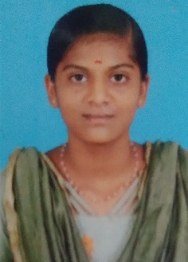

**41/1, Keerai Thotta Street,**

**Keelapavoor,**

**Alangulam (T.K), Mobile No: 9025479194**

**Tenkasi (DT) – 627 806 Email id: csanthiyakpr@gmail.com**

Objective:

**To have growth oriented and challenging career, where I contribute my knowledge and skills to the organization and enhance my experience through continuous learning.**

Educational Qualification:

|  |  |  |  |
| --- | --- | --- | --- |
| **Qualification** | **Year** | **Institution** | **Percentage** |
| **B.Sc (Computer Science)** | **studying** | **Govt Arts and Science College for Women, Alangulam.** | **-** |
| **HSC** | **2020-2021** | **Avvaiyar Govt Girls Hr Sec School, Pavoorchatram.** | **84.05%** |
| **SSLC** | **2018-2019** | **Nadar Hindu High School, Keelapavoor.** | **79.6%** |

Computer Skills

* **Basic of C, C++, Java**
* **Designing skill the HTML VB**
* **Python**

Personal Trait

* **Problem solving ability**
* **Self Motivated**
* **Positive thinker**
* **Typewriting (lower, higher)**

Hobbies

* **Reading Books**
* **Drawing**
* **Speech**

Personal Details

**Name : C. Santhiya**

**Father Name : S. Chermakani**

**Date of Birth : 05/04/2004**

**Sex : Female**

**Nationality : Indian**

**Marital Status : Unmarried**

**Languages Known : Tamil, English**

**Personally : Good**

Declaration:

**I hereby declare that the above information is true to the best of my knowledge and belief.**

**Date: 16.03.2023 Signature**

**C. Santhiya.**